

**MIDDLE EAST TECHNICAL UNIVERSITY**

DEPARTMENT OF ELECTRICAL AND ELECTRONICS ENGINEERING

**EE213 ELECTRICAL CIRCUITS LABORATORY TERM PROJECT**

ANALOG AIR CONDITIONER SYSTEM

Term Project Final-Report

**1.INTRODUCTION**

In this project, our goal is to design an analog air conditioner system that contains pulse width modulation circuit to adjust the duty cycle of signals thus the temperature.Then we will convert the signal into a dc voltage according to its duty cycle. Also we will design a sensing unit to measure ambient temperature and then we will compare the desired and ambient temperature by using a difference amplifier circuit. Furthermore, a cooling or heating device will run according to the comparison of the desired and ambient temperature until the desired temperature is reached and the cooling and heating operations should be indicated by using an RGB LED. Finally, our circuit is supposed to enter a mode called idle mode in which no operation occurs.

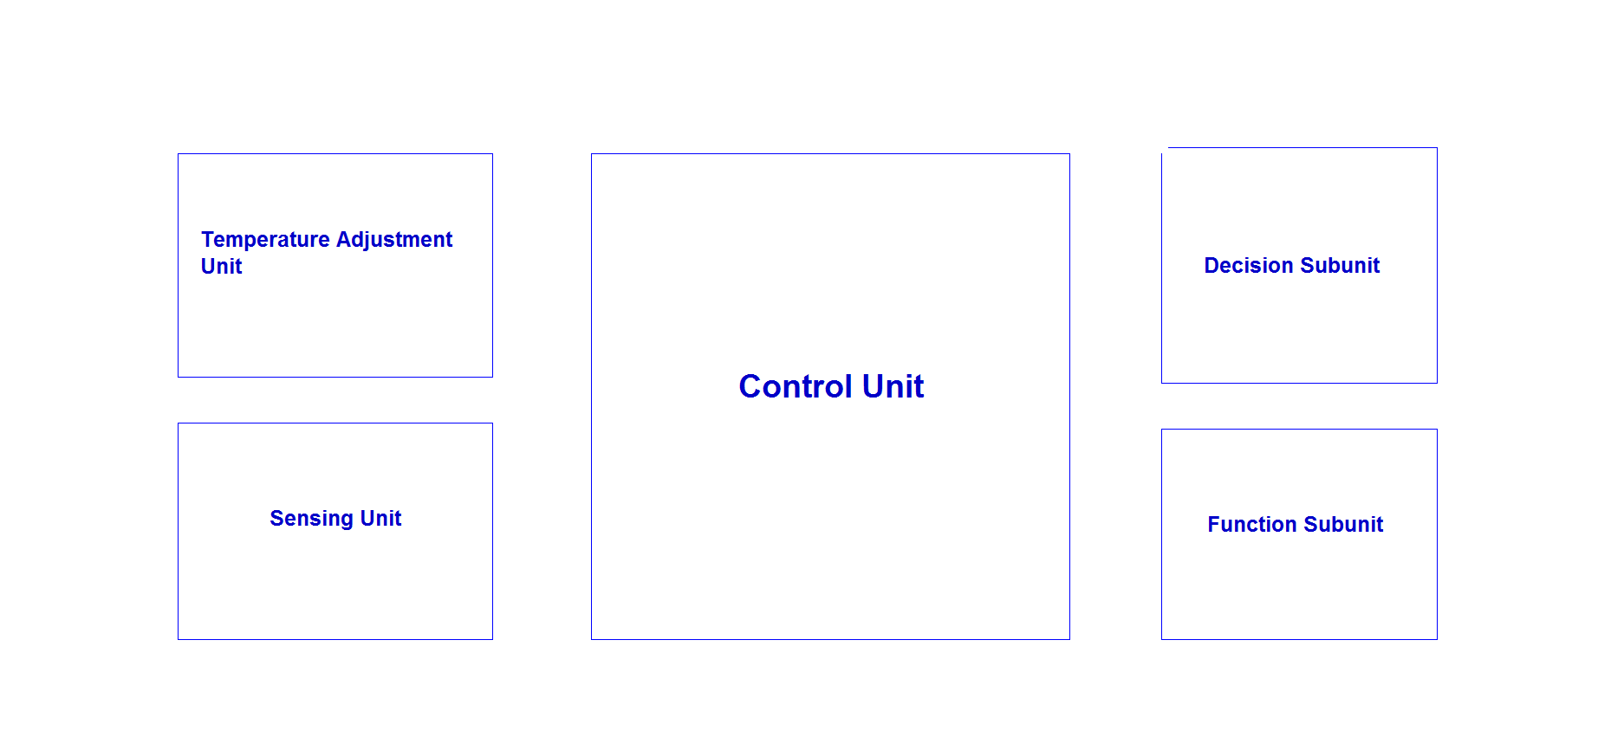

Figure 1 : A general diagram of the project

**2.TEMPERATURE ADJUSTMENT UNIT**

In the first part, in order to adjust the temperature, we design a square wave generator circuit with two diodes in opposite directions and a 10k potentiometer as shown in Figure 2 to generate signals with different duty cycles.Then we will convert these signals into dc voltage according to their duty cycle by using RC low pass filter. Finally, we will divide the voltage to a scale so that we will be able to compare it with the value coming from the sensing unit. We used two different resistors on LTSpice to represent 10k potentiometer.

**a)Rectangular Wave Generator**

Firstly, using the DC source voltage, we obtain rectangular waveform with different duty cycles as shown in Figure 2.In the project we will use a 10k potentiometer instead of R2 and R4. By rotating the potentiometer we will obtain different duty cycles.Since we used a 10k potentiometer, the total resistance will be constant thus the frequency of the wave.

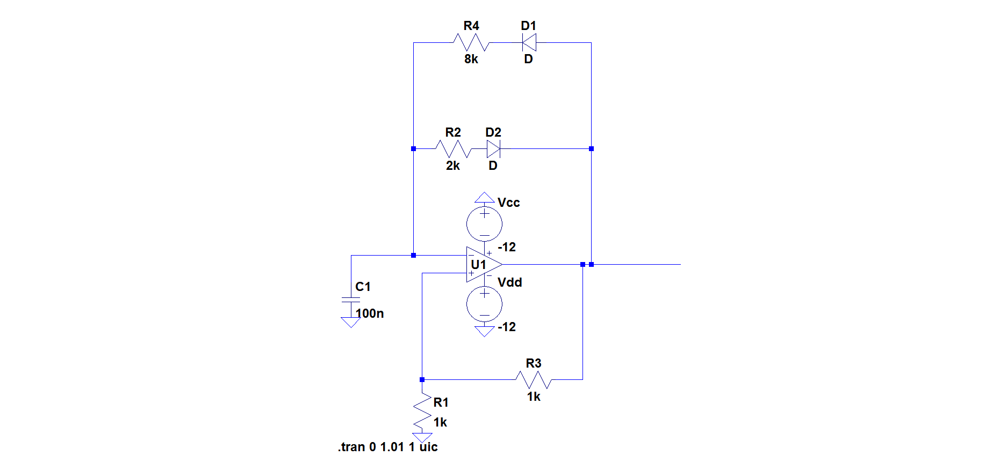

Figure 2 : Rectangular wave generator circuit with different duty cycles

We need to calculate the off time of the output signal :

The general charging formula for the capacitor that has initial charge, q0 ;

q=q0e-t/RC +CV(1-e-t/RC) (1)

Here, V equals Vcc and initial charge q0 = VCC.e-t/RC C.R1/(R1+R3).For our case, R1/(R1+R3)=1/(1+1)=0.5.Therefore, by substituting these values into equation (1) we get ;

q = -CVCC (1-e-t/RC) + 0.5*CVCC e-t/RC

When the capacitor has been fully charged, the other switch takes place.To start it, the charge on the capacitor must equal VCC.R1/(R1+R3).To reach that level, T1 time has to pass.Therefore, at T1, the formula will be as shown;

-CVCC R1/(R1+R3). = -CVCC[1-e-t/RC] + CVCC .e-T1/RC R1/(R1+R3) (2)

So, solving for T1 in equation (2) ;

T1=R2C.ln() (3)

Where C=100nF and R2=2kΩ

Substituting all the values into equation (3) ;

T1=219.7 µs

We need to calculate the on time of the output signal :

The general charging formula for the capacitor that has initial charge q0 is as in (1)

Here, V equals Vcc and initial charge q0 = -VCC.e-t/RC C.R1/(R1+R3).For our case, R1/(R1+R3)=1/(1+1)=0.5.Therefore, for our circuit, charging formula is

q = CVCC (1-e-t/RC) - 0.5*CVCC e-t/RC

When the capacitor has been fully charged, the other switch takes place.To start it, the charge on the capacitor must equal -VCC.R1/(R1+R3).To reach that level, T2 time has to pass.Therefore, at T2, the formula will be as shown;

CVCC R1/(R1+R3). = CVCC[1-e-t/RC] - CVCC .e-T1/RC R1/(R1+R3)

So, solving for T2;

T2=R4C.ln()

Where C=100nF and R4=8kΩ

Substituting all the values, T2=878.9 µs

Therefore the period and the frequency of the signal are calculated in equations (4) and (5) respectively :

T=T1+T2  (4)

T=1.1ms

f=1/T =910.75Hz (5)

Duty cycle of a rectangular wave is calculated as follows :

D=(Ton/Ttotal)*100 (6)

By substituting the values we found into equation (6), the duty cycle in our case :

D=(T1/T)*100=%80

When we construct this circuit, we get the output as shown in Figure 3:

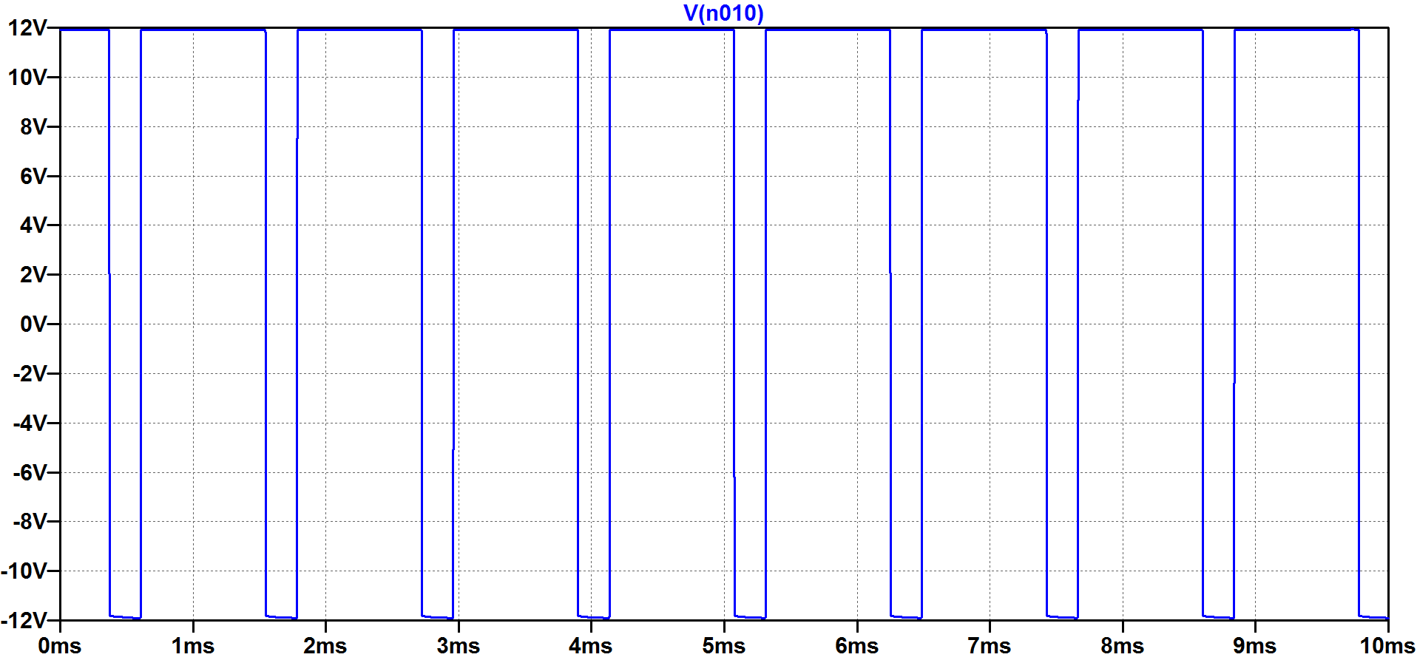

Figure 3 : Vout versus t graph of our rectangular wave generator circuit

**b)Conversion into DC Voltage**

To obtain DC from rectangular wave, we design a two stage RC low pass filter circuit.The RC low pass filter is an electrical circuit that modifies, reshapes or rejects all unwanted frequencies of an electrical signal and accept or pass only those signals wanted by the circuits designer. [1] However, our purpose wasn’t to filter some waves but to get the average of our wave since we have only one frequency value. RC low pass filters pass the waves that has a frequency less than its cut-off frequency. The cut-off frequency of a low pass filter is calculated in equation (7) as follows:

Fc=1/2 $π$ RC (7)

Since the frequency of our rectangular wave is 910.75 Hz, we chose the resistance and capacitance values as shown in Figure 4. Therefore the cut-off frequency of the filter :

Fc=1/2π(2.2k)(150n)=950 Hz

So the filter will pass our wave.

When we choose the capacitance large, the DC value takes more time to reach its stable value. But when we choose it small, the ripples in the DC are significant. Since we want the DC to reach its stable value quickly and don’t want so many ripples, we chose the capacitance small and made the filter two stage to decrease ripples.

Since the filter gives the average of our wave as DC, the output DC voltage is found by the equation (8) :

Vo=Vcc*(|D-%50|)/(%50) (8)

For the signal in the previous part :

Vo=12*(%80-%50)/(%50)

Vo=7.2Volts

For a signal with %30 duty cycle :

Vo=12*(%50-%30)/%50

Vo=-4.8 Volts

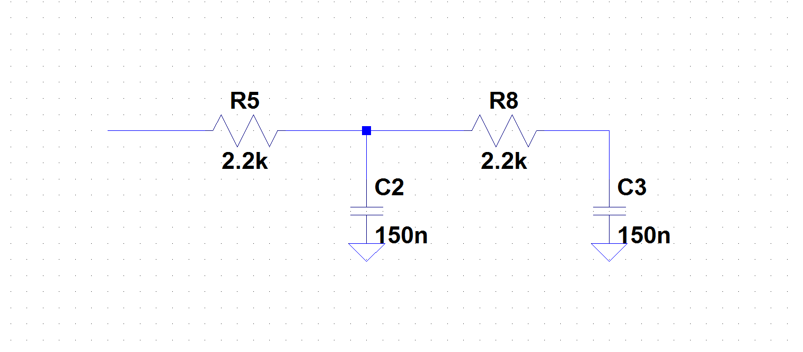

Figure 4 : Two stage RC low pass filter circuit

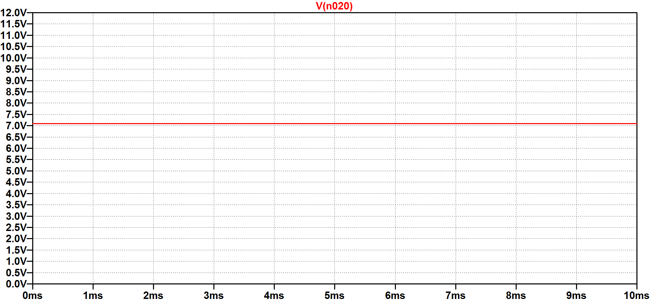

Figure 5 : Vo versus t graph of two stage low pass filter when the duty cycle is %80

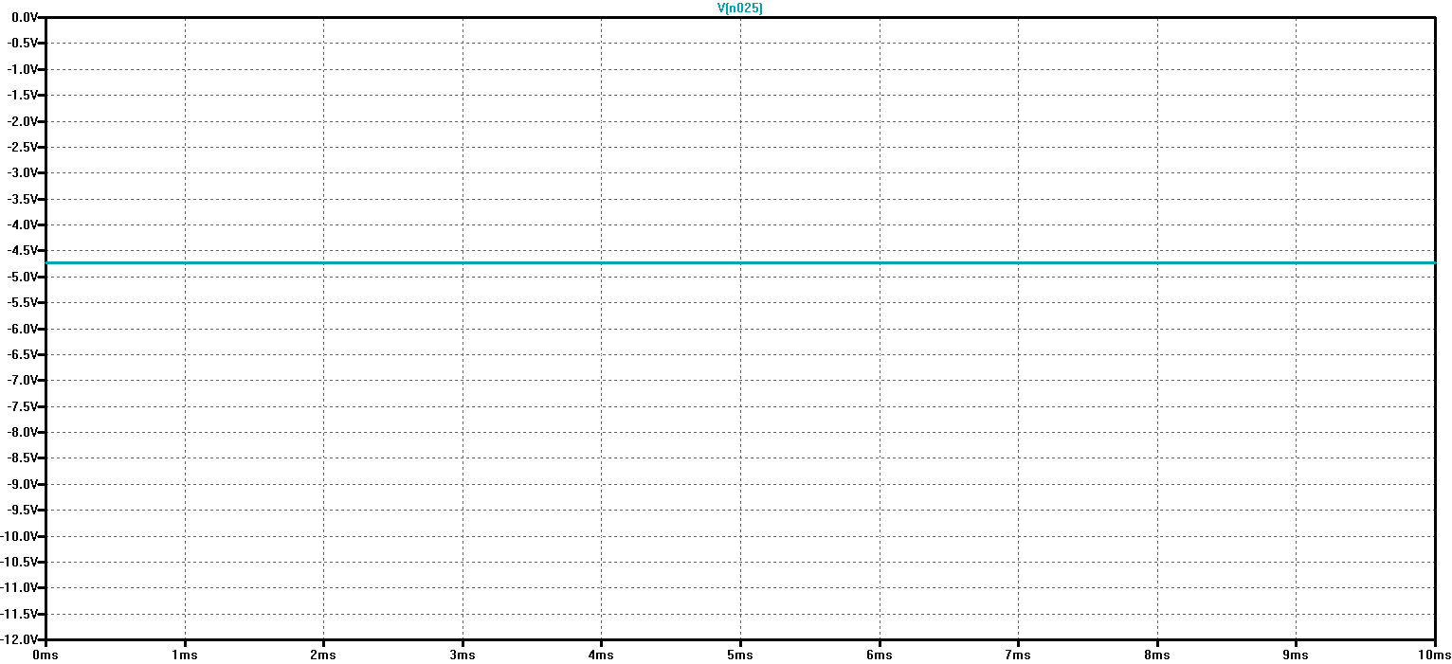

Figure 6 : Vo versus t graph of two stage low pass filter when the duty cycle is %30

The figures 5 and 6 are consistent with the theory. At first we used different capacitance values, but when we tried them in the laboratovary, we got wrong results. After doing more research we chose these values and they gave correct results in the laboratovary.

**c)Scaling the DC Output in part b**

In this part of the project, we are required to scale the DC value of part b so that we will be able to compare it with the output coming from the sensing unit.

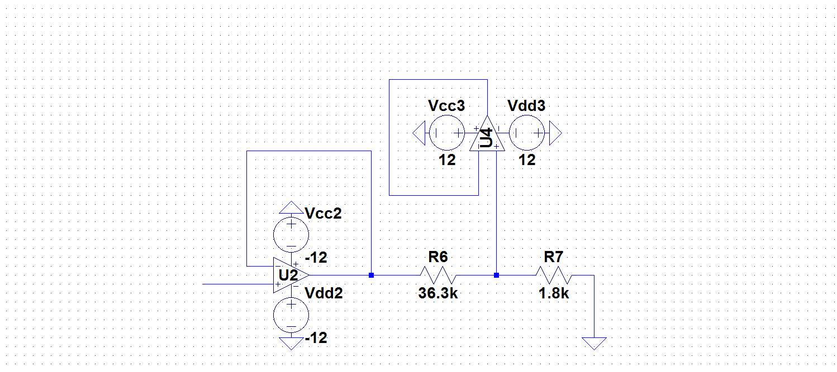

Figure 6 : Voltage division circuit to scale the output in part b

We use two buffers because voltage is divided multiple times and we want to obtain the same voltage at the output with inputs. We chose these resistance values such that output value of this circuit will be comparable with the output of the sensing unit. That is the reason why we should scale this voltage according to the output of the sensing unit. For example, for %80 duty cycle we want to have 300mV but the output in part b is 7.2V. Hence, output of this part will be as in equation (9) :

Voc=Vo*1.8/36.3 (9)

Voc=300mV

**3.SENSING UNIT**

In this part of the project, we are required to measure the ambient temperature.For this purpose, we will use a lm35 temperature sensor.The lm35 sensor gives an output of 10mv per degree Celcius.For our project, we are required to measure between -50 and 50 degrees Celcius.Hence, the maximum and minimum values the sensor will give are 500mV and -500mV respectively[2].

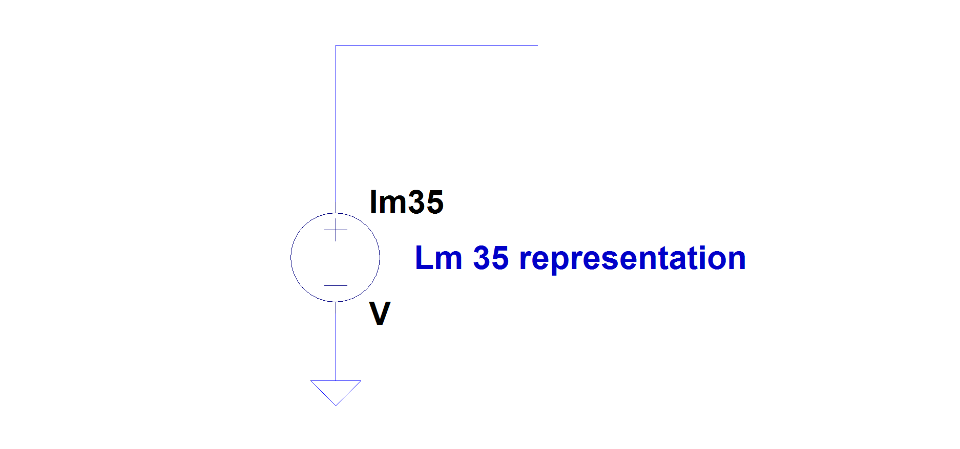

Figure 7 : Lm 35 representation circuit

We put a voltage source instead of lm 35 because there is no lm 35 in ltspice.The voltage range will be between 500mV and -500mV. For instance, the ambient temperature is 25 degrees Celcius, then LM35 sensor will give an output of 250mV as shown in Figure 8.

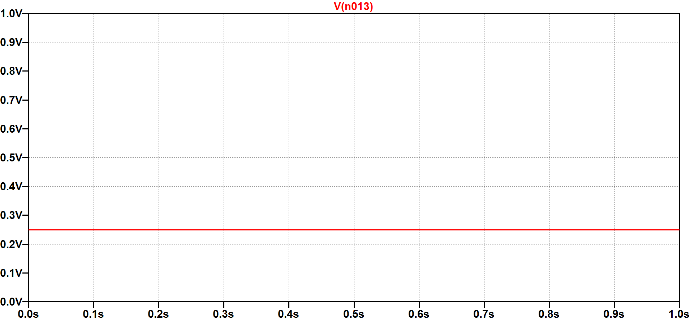

Figure 8 : The output voltage of lm35 when the ambient temperature is 25 degrees

**4.CONTROL UNIT**

Control unit consists of two subunits namely, decision subunit and function subunit.

**4.1)Decision Subunit**

In this part of the project, we are required to compare two signals coming from temperature adjustment and sensing unit and to obtain an output accordingly. For this purpose, we constructed the circuit in Figure 9.

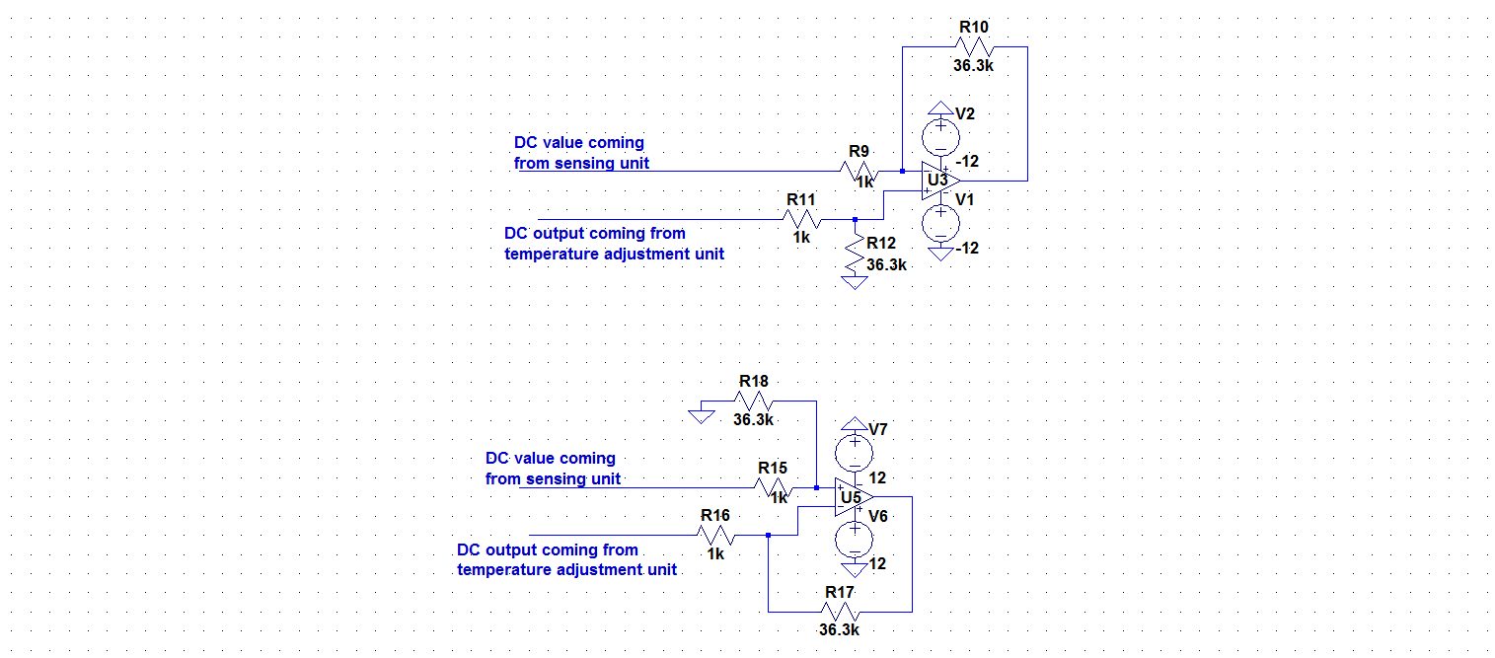

Figure 9 : Difference amplifier circuit to compare ambient and desired temperature

In this circuit, we try to compare desired and ambient temperatures in a 4 degrees Celcius window.If the ambient temperature is 2 degrees greater than desired temperature the op amp U4 will give positive output.If the desired temperature is 2 degrees greater than the ambient temperature the op amp U3 will give positive output. The calculation of output voltage when the op amps are in linear mode is as in equation (10) :

Vo=(R10/R9)*(Vd-Va) (10)

When the difference between ambient and desired temperatures is 2 degrees Celcius i.e. the voltage difference will be 20mV. Thus, when we insert these values into equation (10), the output will be :

Vo=(36.3k/1k)*20mV=726mV

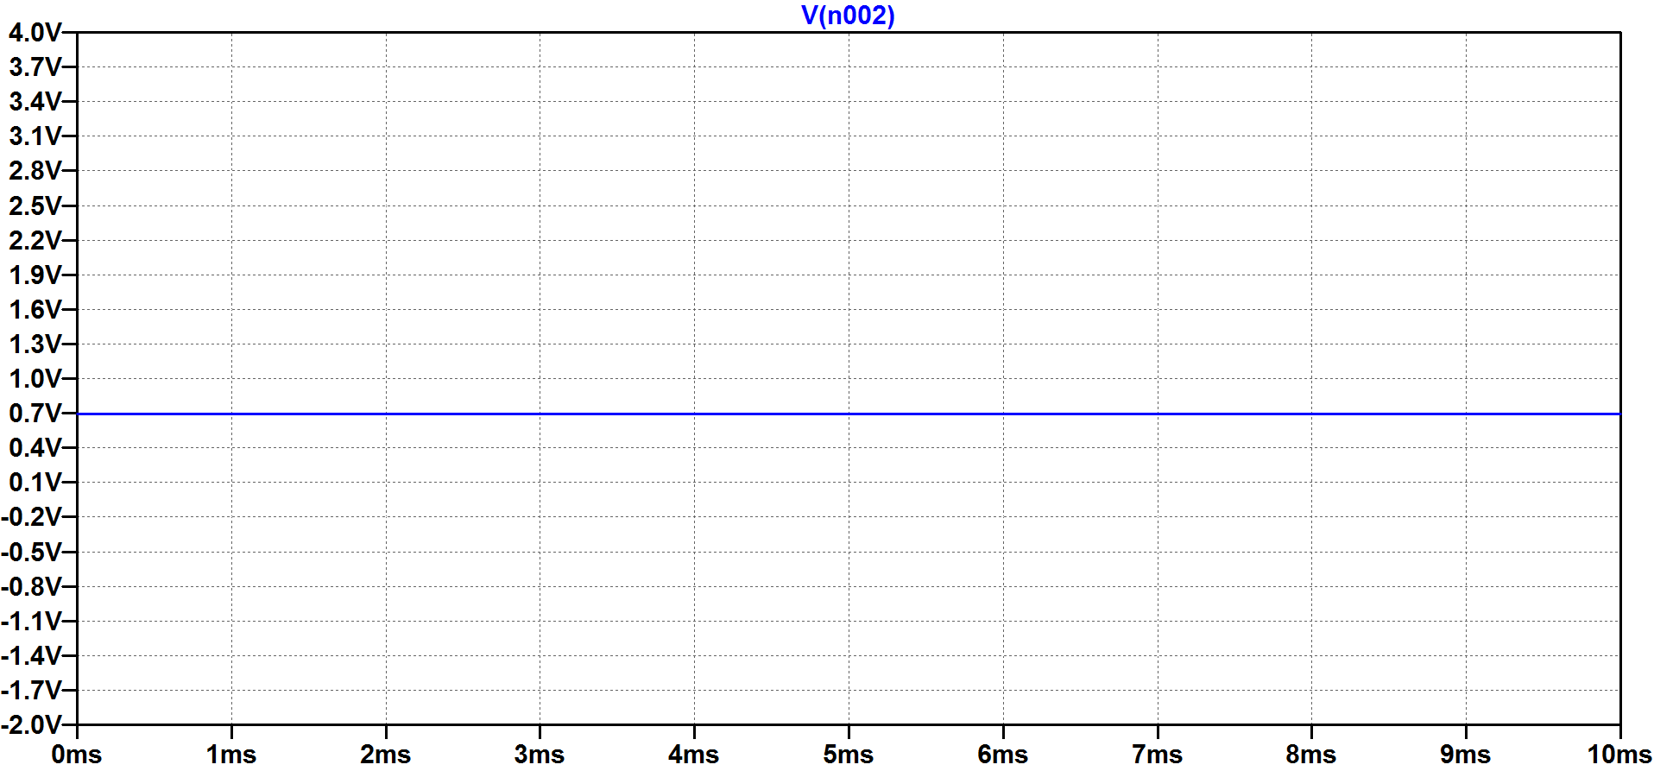

Figure 10 : Vo versus t graph of the op amps when the difference in temperatures is 2

We observe a 726mV of output from U4 when Va-Vd is equal to 20mV and from U3 when Vd-Va is equal to 20mV as shown in Figure 10. The op amps are in linear mode when -340mV<Va-Vd<340mV for both of the op amps.

**4.2)Function Subunit**

In this part of the project, we are required to run the fan or stone resistor according to our desired and ambient temperatures.If the desired temperature is 2 degrees higher than the ambient temperature, our fan needs to start working.If the ambient temperature is 2 degres higher than the desired temperature, current through our stone resistor should flow.If the difference between desired and ambient temperature is less than 2 degrees, neither our fan nor our stone resistor should operate and this state is called idle mode. For this purpose, we constructed the circuit in Figure 11.

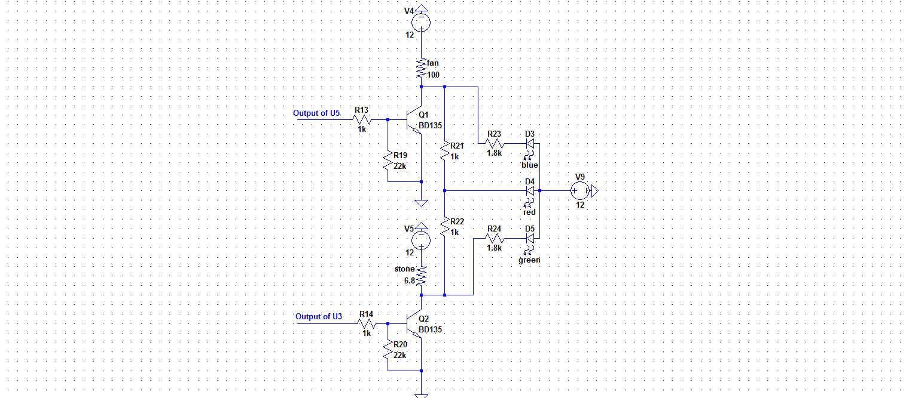

Figure 11 : The circuit diagram for the function subunit

BD135 transistor lets current from collector to emitter if the voltage difference between collector and base of the transistor is greater than 0.7 volts[3].The voltage at the base of the transistor will be 0.7 when the difference between desired and ambient temperature is 2 degrees Celcius.Therefore, nothing will work when there is a difference less than 2 degrees between desired and ambient temperature.When heating is on, led will be yellow,mixture of red and green.When cooling is on, led will be purple, mixture of red and blue.When the idle state is on led will not emit any light.For our example let’s assume our duty cycle is %80 thus the desired temperature is 30 degrees Celcius and our ambient temperature is 25 degrees Celcius.Then, according to our solution, there will be current flowing through the stone resistor, namely the heating is on and RGB LED emits yellow light.

For this example, Q1 transistor does not let current flow from its collector to emitter and the fan does not work.However, the base voltage of Q2 is 1.75V as shown in Figure 10, so there will be current flowing through the stone resistor.Red and green LEDs will light because the heating process is on.Output voltage of U3 is calculated as follows:

Vo=(R19/R18)*(Va-Vd) (11)

By inserting necessary values into equation (11) :

Vo=36.3*50mV=1.81V

The voltage at the base of BD135 will be divided as follows:

Vb=1.81*22k/23k=1.75V

Another reason why we use transistor in this project is that the output current from LM358 op amps is not enough to drive the fan or heat the environment.The maximum current from LM358 is 40mA[4] but we need at least 0.15A. However, in Ltspice BD135 is not present so, we can not get an output of 0.15A.

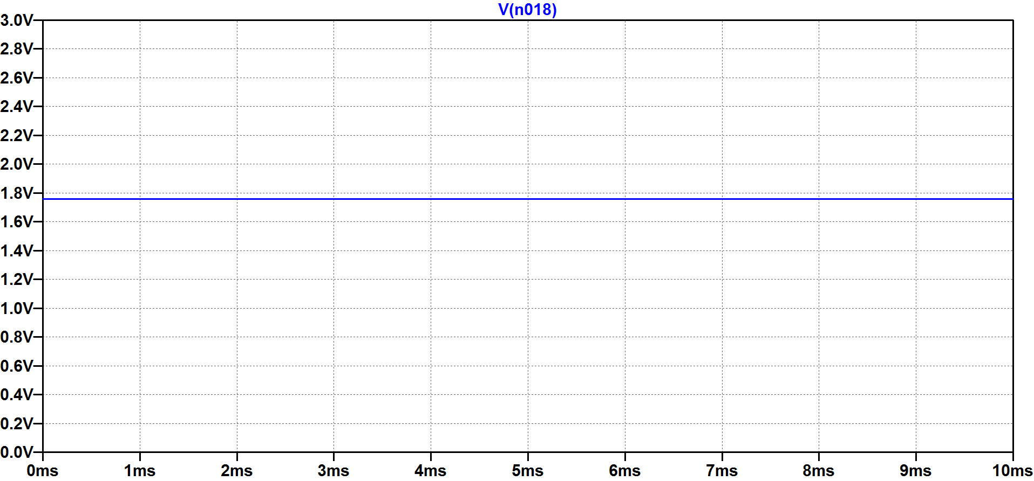

Figure 12 : Base voltage of Q2 when desired temp=30 degrees and ambient temp=25 degrees

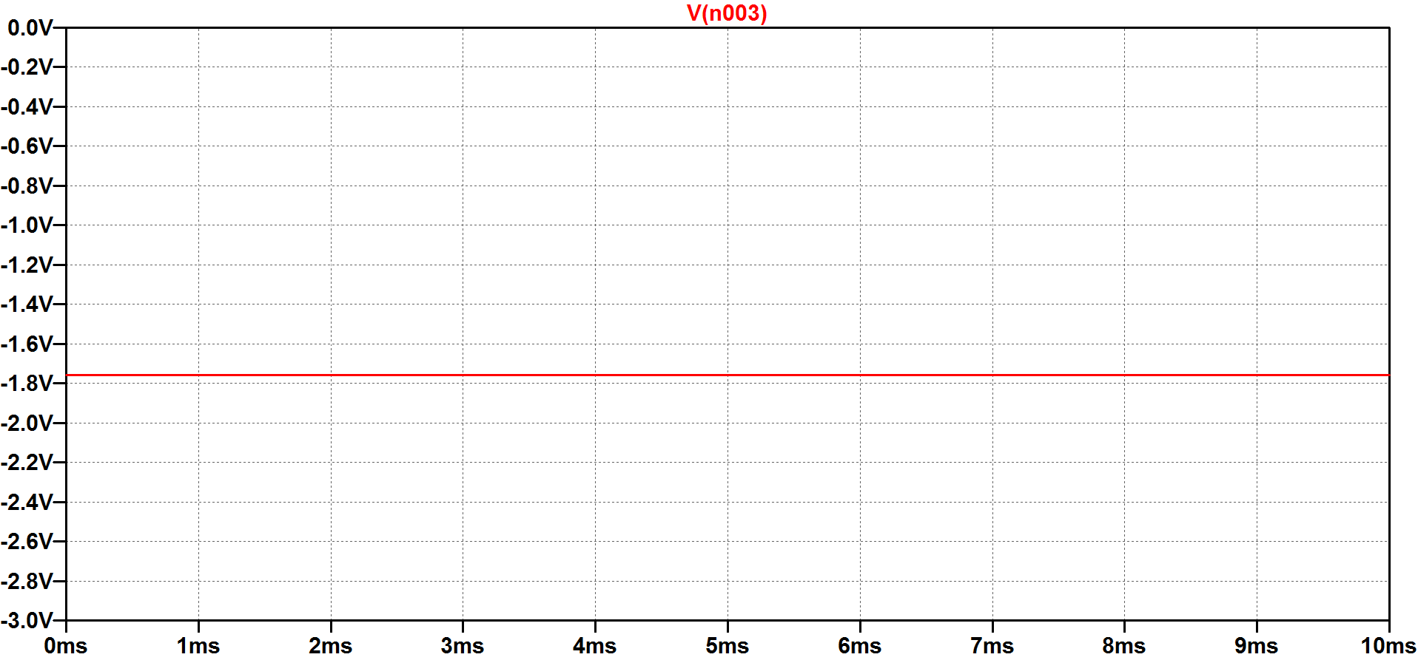

Figure 13 : Base voltage of Q1 when desired temp=30 degrees and ambient temp=25 degrees

The simulation results of the base voltages of Q2 and Q1 are as shown in Figure 12 and Figure 13 respectively when the desired temperature is 30 degrees and the ambient temperature is 25 degrees. As expected, there is positive voltage of 1.75V at the base of Q2 and BD135 will let current from its collector to emitter and the stone resistor will be heated. Also, there is negative voltage of -1.75V at the base of Q1 and thus no current will flow through the cooling fan since the base voltage is less than 0.7V when temperature difference is less than 2 degrees Celcius. At first, we didn’t have voltage division at the base of the transistors. However, we got different results in the laboratovary and the circuit didn’t behave stable since there is open circuit at the base of the transistors. Then we tried this method so that there will always be current flow before the base of the transistors.

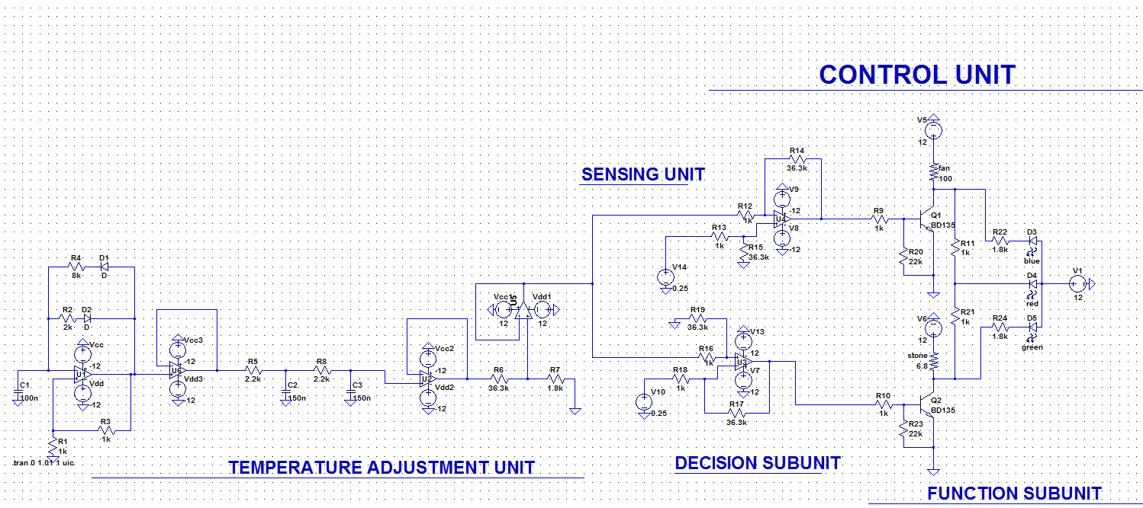

Figure 14 : Detailed circuit schematics of the overall project

Generally, our circuit is designed such that the heating operation is on when the desired temperature is 2 degrees higher than the ambient temperature and the cooling operation is on when the ambient temperature is 2 degrees higher than the desired temperature until the difference between the temperature is less than 2 degrees. When this goal is reached, the system enters into the idle mode so that there will be no operation until the difference in temperatures exceeds 2 degrees.

**5)POWER CONSUMPTION**

When the cooling operation is on:

In order to calculate the power consumption, we measured the currents coming from DC supplies 12Volts and -12 Volts and multiplied them with the corresponding voltages.

P=12V*160mA+12V*10mA=2040mW=2.04W

When the heating operation is on:

Similarly we get the power consumption as the following;

P=12V*140mA+12V*10mA=1800mW=1.8W

When the circuit is in the idle mode:

Similarly we get ;

P=12V*10mA+12V*10mA=240mW=0.24W

**6) COST ANALYSIS**

|  |  |  |  |
| --- | --- | --- | --- |
| Name of the component | Unit price of the component | Number of components used | Total price |
| Lm358 Op-Amp | 50 kurus | 4 | 2 TL |
| 1N4007 Diode | 5 kurus | 2 | 10 kurus |
| 10k Ω Potentiometer | 80 kurus | 1 | 80 kurus |
| Capacitors | 20 kurus | 3 | 60 kurus |
| Resistors | 1 kurus | 27 | 27 kurus |
| BD135 Transistor | 60 kurus | 2 | 1.2 TL |
| 6.8 Ω Stone Resistors | 20 kurus | 1 | 20 kurus |
| RGB LED | 25 kurus | 1 | 25 kurus |
| LM35 temperature sensor | 3 TL | 1 | 3 TL |
| Breadboard | 7 TL | 2 | 14 TL |
| Cooling fan | 6 TL | 1 | 6 TL |
| Cables | 50 kurus per meter | 0.5 meter | 25 kurus |

In total, this project costed us 28.67 TL.

**7)CONCLUSION**

In conclusion, in this project, we learned how to use pulse width modulation in our circuits to adjust a value by generating rectangular waves with different duty cycles. Also, we learned how to convert a rectangular wave into DC and compare two values in an interval.We briefly learned the usage of transistors, RGB LEDs and temperature sensors. We encountered so many problems in practice and did a lot research to overcome these problems. One of the problems was that the RC low pass filter didn’t give correct results. After doing some research we understood that we should use the values in this report. Almost all our units were affected by each other at first so we used buffers at every step to make sure they aren’t affected. LM35 gave different results as we changed the duty cycle until the demonstrations but we overcame this problem by connecting the power supplies near the components and by connecting a buffer at the output of LM35. The circuit didn’t enter idle state since our transistors didn’t work properly but we partially overcame this problem by setting a voltage division circuit before the base of the transistors. We mainly used what we learned in the experiments of EE213. We understood the importance of making a thorough research while trying to solve an engineering problem. Finally, this project was a good chance to improve our technical skills in engineering.

**REFERENCES**

[1] Low pass filter - passive RC filter Tutorial. (2013, August 14). Retrieved from http://www.electronics-tutorials.ws/filter/filter_2.html

[2] LM35 Precision Centigrade Temperature Sensors. Retrieved from http://www.ti.com/lit/ds/symlink/lm35.pdf

[3] Retrieved from http://www.onsemi.com/pub_link/Collateral/BD135-D.PDF

[4] LMx58-N Low-Power, Dual-Operational Amplifiers. Retrieved from http://www.ti.com/lit/ds/symlink/lm158-n.pdf